Internet and Web Programming

CSE3002

Fall Semester 2020-21

Lab Assignment 1

**ISHAAN OHRI**

**18BCE0265**

**Question:**

Design a website to demonstrate the knowledge of students in HTML tags, forms, table, list and HTML frames.

1. Create a user registration webpage using HTML Form elements (Input types) for a hackathon event registration. The webpage must contain the following input types to get the details of the students
2. # Input Types:- Textfields, Textarea, checkbox, radio button, submit button, reset button, drop down box, images (if required).
3. # Apply styles, Formatting tags of HTML for good design.
4. # Embed audio or video.
5. # Perform form validations with HTML 5 elements.

**Procedure:**

<!DOCTYPE html>: Tells browser that it is an HTML document

<head>: Container for header elements

<title>: Name for toolbar

<body>: Body element for document

<style>: Styles for the different elements

<h1>: Heading of level 1

align: alignment on the HTML document

<form>: Creates an HTML form for user input

action: backend script to process data

method: API request method

<table>: Defines a table

cellpadding: Space to left on all 4 sides inside the cell

<tr>: Defines a new table row

<td>: Defines a cell

<input>: Declare input controls that allow users to input data.

type: Defines the type of input text/radio/checkbox

name: Defines the name of the <input> element

id: Unique id to identify

pattern: Defines pattern of input data

required: Compulsory to enter

value: Defines the value of the option in radio/checkbox

<label>: Represents a caption for an item in a user interface

For:

<textarea>: Multi-line text input control

rows: Min no of rows

cols: Min no of cols.

<select>: Used to create dropdown list

<option>: Define options for dropdown

<p>: Defines a paragraph

<iframe>: Defines an inline frame. Used to embed another document, in this case video

width: Defines width of element

height: Defines height of element

src: Source of media

allow: Enables extra restrictions for media hosted by iframe

allowfullscreen: Allow in full screen

<img>: Inserts image

**Code:**

<!DOCTYPE html>

<html lang="en">

<head>

<meta charset="UTF-8">

<meta name="viewport" content="width=device-width, initial-scale=1.0">

<title>18BCE0265 IWP Lab DA - 1</title>

</head>

<style>

body{

background-color: rgb(20,20,20);

font-family: Verdana, Geneva, Tahoma, sans-serif;

color: rgb(16, 229, 125);

}

h1{

font-size: 3em;

}

#nameHeading,

#regNoHeading,

#emailHeading,

#mobNoHeading,

#ideaHeading,

#yearHeading,

#branchHeading,

#domainHeading{

font-size: 1.2em;

font-weight: 700;

font-family: Verdana, Geneva, Tahoma, sans-serif;

}

#name,

#regNo,

#email,

#mobNo,

#idea{

height: auto;

width: auto;

padding: 5px 10px 5px 10px;

text-transform: capitalize;

background-color: rgb(20,20,20);

border: 2px solid rgb(156,156,156);

border-radius: 5px;

color: white;

font-size: 1.2em;

font-family: Verdana, Geneva, Tahoma, sans-serif;

}

#mobPrefix{

border: 1px solid rgb(156,156,156);

border-radius: 5px;

}

div,

#first,

#second,

#third,

#fourth{

font-size: 1.2em;

font-family: Verdana, Geneva, Tahoma, sans-serif;

}

</style>

<body>

<h1 align="center">Hackathon Registration</h1>

<form action="submit" method="post">

<table align="center" cellpadding=10>

<tr>

<td>

<label id="nameHeading" for="name">Name</label><br>

</td>

<td>

<input type="text" id="name" name="name" required>

</td>

</tr>

<tr>

<td>

<label id="regNoHeading" for="regNo">Registration Number</label><br>

</td>

<td>

<input type="text" id="regNo" name="regNo" style="text-transform: uppercase;" required>

</td>

</tr>

<tr>

<td>

<label id="emailHeading" for="email">VIT Email</label><br>

</td>

<td>

<input type="email" id="email" name="email" style="text-transform: lowercase;" pattern="[1-9]{2}[A-Z]{3}[0-9]{3}[1-9]" title="Enter valid registration number" required>

</td>

</tr>

<tr>

<td>

<label id="mobNoHeading" for="mobNo">Mobile Number</label><br>

</td>

<td>

<input type="text" id="mobNo" name="mobNo" pattern="[1-9][0-9]{9}" title="Enter valid mobile number" required>

</td>

</tr>

<tr>

<td>

<label id="ideaHeading" for="ideaHeading">Idea Description</label><br>

</td>

<td>

<textarea type="text" id="idea" name="idea" cols="25" rows="5" required></textarea>

</td>

</tr>

<tr>

<td>

<label id="yearHeading" for="yearHeading">Year</label><br>

</td>

<td>

<label id="first" for="">First</label>

<input name="year" type="radio" value="first" checked>

<label id="second" for="">Second</label>

<input name="year" type="radio" value="second">

<label id="third" for="">Third</label>

<input name="year" type="radio" value="thirst">

<label id="fourth" for="">Fourth</label>

<input name="year" type="radio" value="fourth">

</td>

</tr>

<tr>

<td>

<label id="branchHeading" for="branch">Branch</label>

</td>

<td>

<select name="branch">

<option>Computer Science Engineering</option>

<option>Information Technology Engineering</option>

<option>Electronics and Communication Engineering</option>

<option>Electronics and Electrical Engineering</option>

<option>Electronics and Instrumentation Engineering</option>

<option>Civil Engineering</option>

<option>Chemical Engineering</option>

<option>Mechanical Engineering</option>

</select>

</td>

</tr>

<tr>

<td>

<label id="domainHeading">Domain</label>

</td>

<td>

<div id="checkbox">

<label for="">Backend</label>

<input name="role" class="role" type="checkbox" value="backend">

<label for="">Web</label>

<input name="role" class="role" type="checkbox" value="web">

<label for="">App</label>

<input name="role" type="checkbox" value="app">

<label for="">Designer</label>

<input name="role" type="checkbox" value="designer">

<label for="">Other</label>

<input name="role" type="checkbox" value="other">

</div>

</td>

</tr>

<tr>

<td>

<input type="submit" value="Submit">

<input type="reset" value="Clear">

</td>

</tr>

</table>

<table align="center" cellpadding="20">

<tr>

<td>

<iframe width="600" height="300" src="https://www.youtube.com/embed/DPnqb74Smug" frameborder="0" allow="accelerometer; autoplay; encrypted-media; gyroscope; picture-in-picture" allowfullscreen></iframe>

</td>

</tr>

</table>

</form>

<p style="text-align: center;">

<img src="./banner.jpg"height="150" align="center">

</p>

</body>

</html>

**Output:**

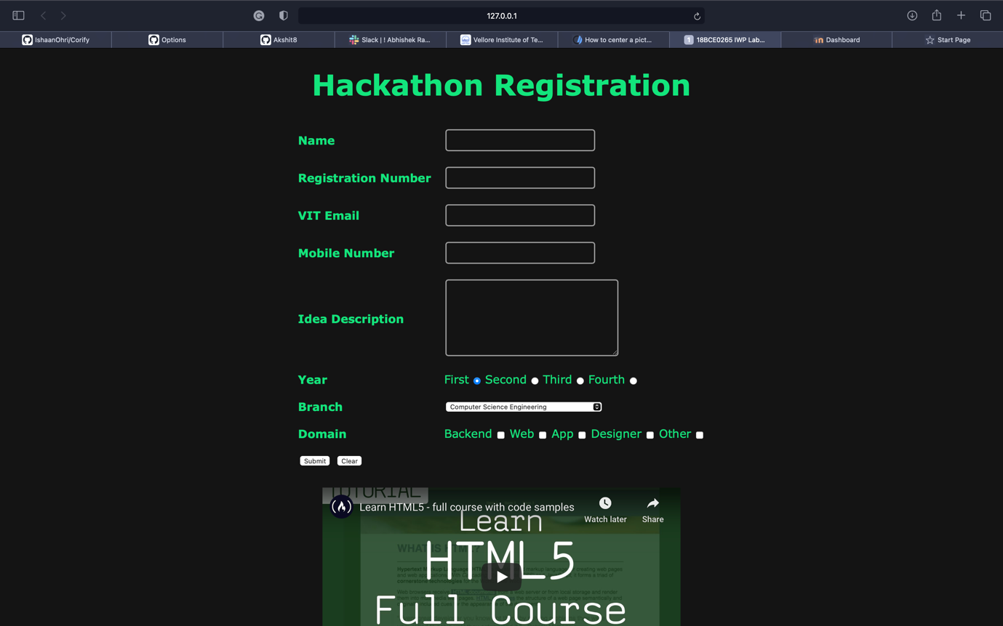

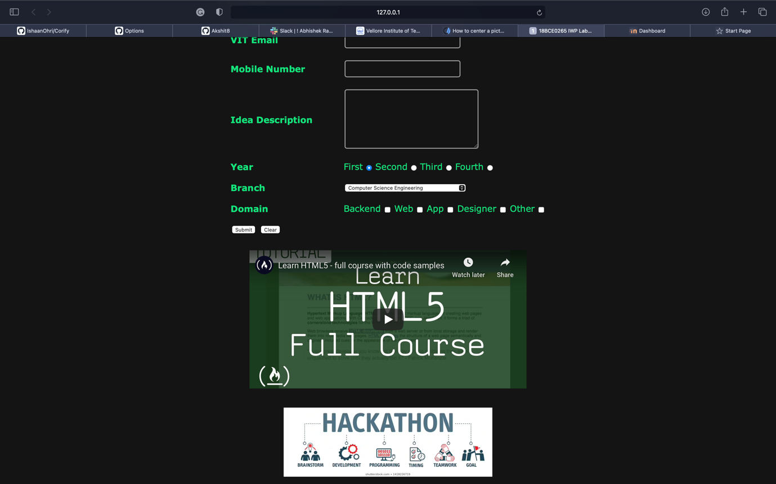

**Question:**

Write a program to demonstrate the concept of HTML Image mapping element.

1. Add an image of the cricket playground.
2. Use image mapping to give the details about the various fielding positions.(eg.Gully, slip etc., - write description about it and your favourite fielders at that point)

**Code:**

**index.html**

<!DOCTYPE html>

<html>

<head>

<title>18BCE0265 ISHAAN OHRI</title>

</head>

<body>

<p>CLICK ON FIELDING POSITION TO KNOW MORE INFORMATION</p>

<img src="ground.png" width="674" height="674" alt="Planets" usemap="#fielding-position">

<map name="fielding-position">

<area shape="rect" coords="315,240,355,280" alt="keeper" onclick="keeper()">

<area shape="rect" coords="200,460,240,500" alt="mid-off" onclick="midoff()">

<area shape="rect" coords="460,300,500,340" alt="mid-wicket" onclick="midwicket()">

<area shape="rect" coords="180,300,220,340" alt="point" onclick="point()">

<area shape="rect" coords="450,90,490,130" alt="fine-leg" onclick="fineleg()">

<area shape="rect" coords="100,140,140,180" alt="third-man" onclick="thirdman()">

</map>

<iframe id="iframe" height="400" width="400" style="border: 1px solid white;"></iframe>

</body>

<script>

function keeper() {

document.getElementById("iframe").src="keeper.html";

}

function midoff() {

document.getElementById("iframe").src="mid-off.html";

}

function midwicket() {

document.getElementById("iframe").src="mid-wicket.html";

}

function point() {

document.getElementById("iframe").src="point.html";

}

function fineleg() {

document.getElementById("iframe").src="fine-leg.html";

}

function thirdman() {

document.getElementById("iframe").src="third-man.html";

}

</script>

</html>

**fine-leg.html**

<!DOCTYPE html>

<html>

<body>

<h1 align="center">Fine Leg - Rohit Sharma</h1>

<img src="rohit.png" alt="fine-leg"/>

</body>

</html>

**keeper.html**

<!DOCTYPE html>

<html>

<body>

<h1 align="center">Wicket Keeper - MS Dhoni</h1>

<img src="dhoni.png" alt="keeper"/>

</body>

</html>

**mid-off.html**

<!DOCTYPE html>

<html>

<body>

<h1 align="center">Mid Off - Virat Kohli</h1>

<img src="kohli.png" alt="mid-off"/>

</body>

</html>

**mid-wicket.html**

<!DOCTYPE html>

<html>

<body>

<h1 align="center">Mid Wicket - Hardik Pandya</h1>

<img src="hardik.png" alt="mid-wicket"/>

</body>

</html>

**point.html**

<!DOCTYPE html>

<html>

<body>

<h1 align="center">Point - Ravindra Jadeja</h1>

<img src="jadeja.png" alt="point"/>

</body>

</html>

**third-man.html**

<!DOCTYPE html>

<html>

<body>

<h1 align="center">Third Man - Ishaan Ohri</h1>

<img src="ishaan.png" alt="third-man"/>

</body>

</html>

**Output:**



